
名称：全自动高速铣槽机  型号：ICM-6000  用途：用于在ISO7816标准卡上铣槽 ，特别适合双界面卡  片高精度要求铣槽。  优势：1、铣槽精度高，特别适合对精度要求较高的槽位的生  产，如双界面卡铣槽。  2、产品电路符合CE标准，操作安全可靠  3、每个锣头可单独通过软件界面编辑多达5层不同规  格的铣槽，且两个锣头可以铣不同的图形。  4、每层铣槽走刀路径，起点，终点位置用户可以自己  编辑，使用户更加方便控制铣槽质量及铣槽速度。  5、软件密码级别设置，不同级别密码可设置不同参数  管理 权限，如操作员密码，管理员密码 | 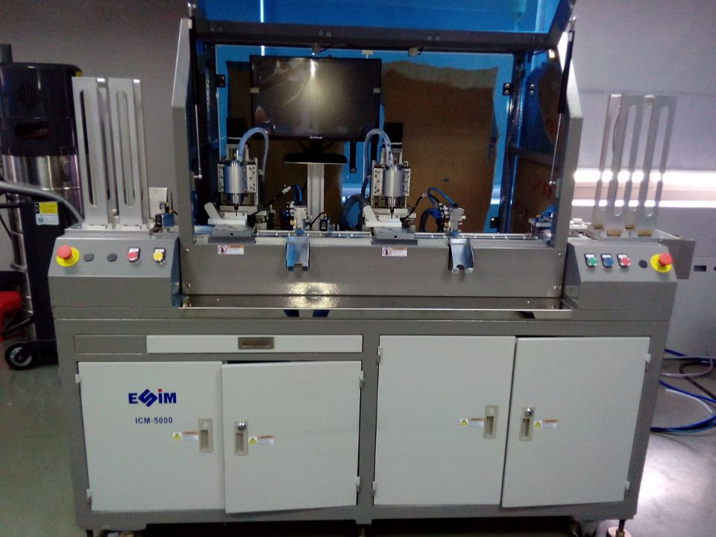
功能及特性：
1、ICM-6000全自动高精度铣槽机采用研华IPC加安川高精度伺服系统控制。
2、双卡匣设计，一次送两张卡到传送皮带。
3、铣槽前卡片方向检测，放置反的卡片自动剔除。
4、传送皮带采用卡片纵向送料,使机器结构更紧凑,传动快捷准确。
5、采用机械方式定位，定位精度远高于传统气缸定位，夹具采用四组进口轴承导向，铣槽时保证卡片压紧。
6、采用高速水冷锣头,确保高速运转精度,延长刀具及锣头使用寿命。
7、双锣头铣槽设计,一次同时完成两张卡铣槽, 加工效率高。
8、修改槽的尺寸可直接在专用的生产软件界面编制图形输入完成，设定时图形示意图即时呈现,操作方便直观。
9、具有铣槽时及铣槽后的两次气动全封闭吸尘清洁装置，确保吸尘干净。
10、铣槽后装有电性能检测工位检测双界面卡线圈通断，不良卡会被排到尾部废卡盒。
11、设备左右急停按钮,方便操作;设备有良好接地,安全可靠。
12、设备装有安全门禁开关,运行中开门将自动停机,确保操作安全。
技术规格：
类 别 | 内容描述 | 类 别 | 内容描述
最大铣槽尺寸 | 14X14mm ( 可按客户要求配置) | 适用物料 | PVC, ABS, PETG，PC，光面卡，透明料的 ISO7816标准卡
铣槽精度 | X,Y (位置) = +/- 0.05mm  Z(深度) = +/- 0.015mm | 锣头转速 | 1000-25000 转/分钟
产 能 | 5000-6000 张卡/小时 | 产品合格率 | 99.0％
耗气量 | 400L/min | 电 源 | AC380V, 50/60Hz, 3kw（不包括吸尘机）
重 量 | 750 kg | 气 压 | 6kg/cm²，无水与无油。
外形尺寸 | L2000mm×W800mm×H2000mm | 使用环境 | 温度 22℃，+ 3℃，干燥和无尘

声明：以上参数如变更恕不另行通知。

Automatic High Precision IC Card Milling Machine
Model: ICM-6000

Purpose:
For ISO7816 standard card cavity milling, particularly for dual interface cards which requires high-precision cavity milling.

Advantages:
- High accuracy of cavity milling, particularly suitable for high-precision required production, like cavity milling on dual interface card.
- Circuit meets CE requirements. Machine operation is safe and reliable.
- Each spindle can accomplish different cavities with 5 layers. Two spindles deal with different graphics.
- User can edit the milling route, start point, end point of each layer, which is convenient to control the speed and quality of cavity milling.
- The software password has grades. Different grades have different parameter management rights, such as operator password, administrator password.
Features:

- Adopting IPC and Yaskawa high precision servo control system
- Double-magazines design, two cards feeding at the same time
- Card orientation detection before cavity milling which can reject anti-card automatically.
- Transfer belt controlled by servo can feeding automatically, quickly and accurately.
- Mechanical position, whose position accuracy is far higher than that positioned by cylinder. The fixture adopts four sets imported bearings to guide. Cards can be compressed when milling.
- Adopting high-speed, water cooling spindle which ensures high-speed running precision and make bits & spindle longer life time. Dual-spindle design, can mill two cards at one time, processing efficiency is high.
- Cavity dimension adjusted by the specialized production software interface and the sketch shown instantly. The operation is very easy.
- Twice pneumatic enclosed dust vacuum cleaning device on & after milling can ensure dust removed.
- Electrical performance testing to verify the conduction of antenna on dual interface card. Unqualified cards to be rejected into the waste magazine.
- Emergency stop buttons on both sides. Well grounding.
- Safe access control switch. Automatic outage once the door opens.
Specifications:
Item | Details | Item | Details
Max. milling dimension | 14X14mm (configured by clients’ requirements) | Suitable material | PVC, ABS, PETG, PC, smooth card, ISO7816 standard card with transparent film
Milling accuracy | X,Y (position) = +/- 0.05mm  Z(depth) = +/- 0.015mm | Spindle rotate speed | 1000-25000 turns/min
Throughput | 6000 cards/hr (depends on size of cavity) | Yield | 99.0%
Air consumption | 400L/min | Power | AC380V, 50/60Hz, 3KW (excluding vacuum)
Weight | 750 kg | Air pressure | 6kg/cm², clean, dry and oil-free.
Dimension | L2000mm×W800mm×H2000mm | Environment | Constant temperature 22℃, ±3℃, dry and dust free.

Notes: above specification is subject to change without prior notice due to continuous improvement.

