
名称：全自动IC卡封装机  型号：ICI-6000  用途：将条带模块备胶、冲切并封装在已铣槽的卡基上。  优势：1、PLC程序自动控制，中英文触摸屏显示及操作;  2、集备胶、冲切、封装及检测于一体。 | 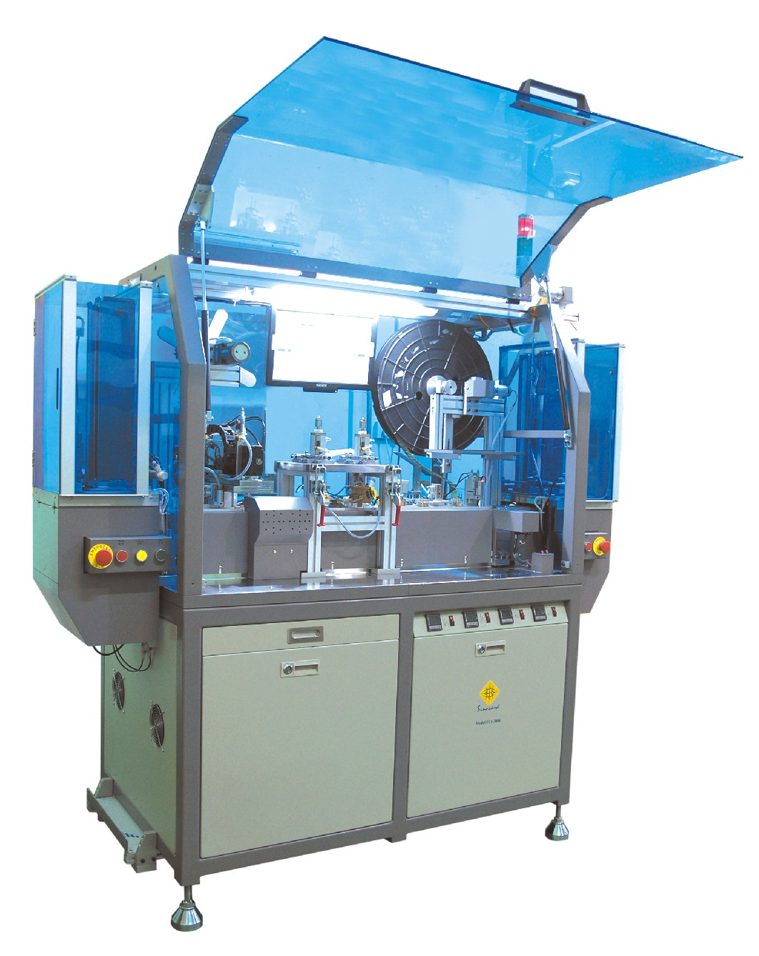  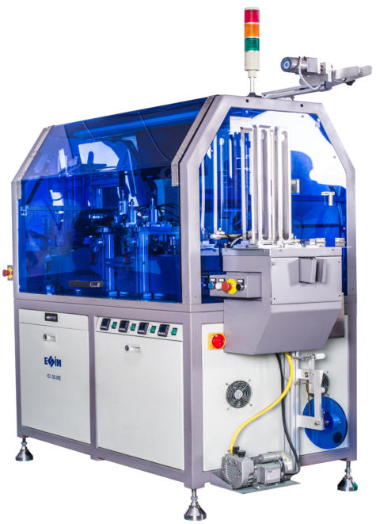
功能及特性：

1、双卡匣自动上下料。
2、自动检测槽位并进行封装。
3、先点焊定位，然后进行热焊A、B二站，最后进行冷压。
4、封装后自动检测，并自动将废卡剔除。
5、自动检测模块，并对坏IC模块进行识别并打孔坏。
6、针对不同模块，可灵活更换备胶、冲切模具。

技术规格：

类 别 | 内容描述 | 类 别 | 内容描述
最高运行速度 | 6000UPH | 适用物料 | PVC, ABS, PET-G材料的ISO7816 标准卡
铣槽驱动精度 | X, Y = +/- 0.015mm | 封装温度 | 100℃ ～300℃可调节
封装压力 | 3 ～ 20Kg/cm² | 重 量 | 2500kg
电源/功率 | AC220V，50/60Hz，1.5KW | 外形尺寸 | (L)1960mm x (W)800mm x (H)2050mm
耗气量 | 250L/min | 使用环境 | 温度 22℃，+ 3℃，干燥和无尘

声明：以上参数如变更恕不另行通知。

Automatic IC Card Implanting Machine  Mode：ICI-6000  Purposes:  The machine is to laminate module tape, punch module from the tape and implant module onto milled plastic cards.  Advantages:  - PLC program control. Chinese/English touch screen and operation.  - Integration of module tape gluing, module punching, module implanting and testing. | 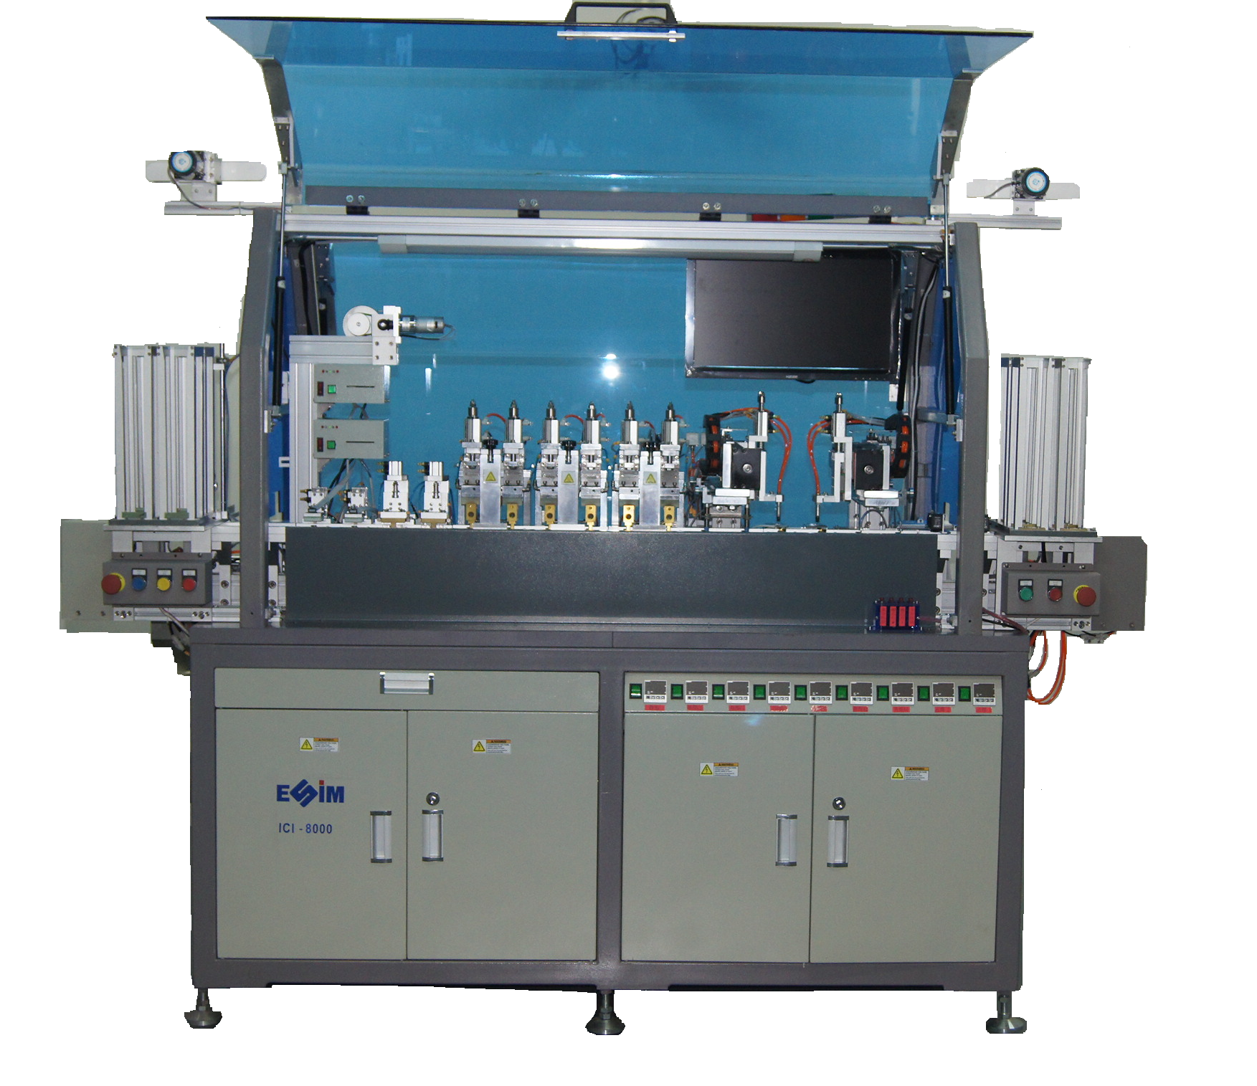
Features:

- Double card magazines to load/unload cards.
- Automatically check card cavity and implant modules.
- Spot weld for positioning, hot weld stations A & B, then cold press.
- Automatically check card after implanting and reject defective cards.
- Identify cards with bad module and punch hole on cards.
- For different module, flexible replacement of tooling of module tape gluing and module punching.
Specifications:

Item | Details | Item | Details
Max. Speed | 6000UPH | Suitable material | ISO7816 standard card of PVC, ABS, PET-G
Milling accuracy | X, Y = ± 0.015mm | Temperature | 100℃ ～300℃ (adjustable)
Implanting pressure | 3 ~ 20Kg/cm² | Weight | 2500kg
Power | AC220V, 50/60Hz, 1.5KW | Dimension | (L)1960mm x (W)800mm x (H)2050mm
Air consumption | 250L/min | Environment | Constant temperature 22℃, ±3℃, dry and dust free.

Notes: above specification is subject to change without prior notice due to continuous improvement.

